# \ COMP30004: Web Technology and Programming

# Module leader: Jan Lawton

# Assignment 1 - Worth 50% of module marks (LO 1,2)

## ****University Regulations****

**The University Regulations regarding extenuating circumstances and academic misconduct will apply. Please ensure that you are familiar with these regulations:**

* <http://www.staffs.ac.uk/legal/policies/Procedure-for-dealing-with-breaches-of-assessment.jsp>
* <http://www.staffs.ac.uk/legal/policies/extenuating-circumstances-regulations.jsp>

## ****Submissions****

* **All submissions are done using Blackboard**
* **All presentations must be uploaded in PowerPoint or PDF format and readable on a PC**
* **All zipped files must be in .zip format NOT .rar**
* **Standard submission rules apply:**
  + **Late submissions attract ZERO marks for that section**
  + **Failure to submit on Blackboard may forfeit your opportunity to present or demonstrate your work**
  + **Failure to attend the presentation or demonstration on time may result in 0 marks for that component of assessed work**

## ****Important Dates****

**Hand in date (electronically on blackboard) – 20/01/20 09:30am**

**Presentation / Demo date – WB 20/01/20 (dates/times to be advised on blackboard)**

## Learning Outcomes

On completion of this module you will be able to:

1. Demonstrate knowledge and understanding of concepts, principles and theories relating to web technologies
2. Design interfaces taking the user into account
3. Design, implement, test and demonstrate computer programs using appropriate tools and techniques
4. Understand procedural and event driven approaches to software development

## Specification

You have been asked to create a client-side web application to show your skills in web development, including web design, creating pages with HTML, styling using CSS, and testing web applications.

The application should be designed so it is a showcase of you and your skills, suitable to market yourself to prospective employers.

The navigation diagram for the application is shown below:

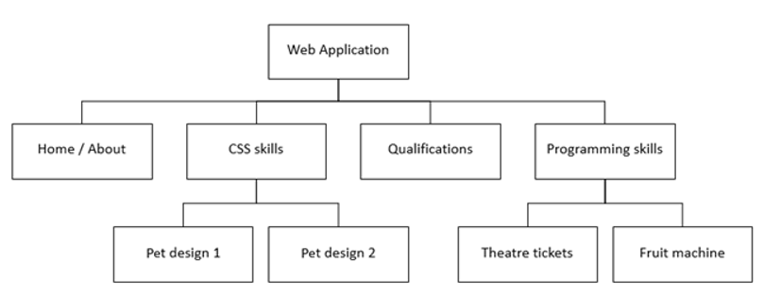

Your application must fulfil the following criteria:

1. Your application as a whole must:

* be created using **JUST** HTML and CSS, and **NO** external web creator tools
* **NOT** contain any external libraries or frameworks
* have 4 HTML pages you have created:
  + Home page / about me page
  + Qualifications page
  + CSS skills page
  + Programming skills page
* have 2 pet pages (the HTML will be provided to you for these pages)

1. Each page MUST contain suitable and appropriate HTML for the following:

* meta tags for character sets, mobile and SEO
* an English language attribute
* a title that is displayed in the browser tab
* at least one header with a first level heading inside it
* a navigation section with links to
  + Home page / about me page
  + Qualifications page
  + CSS skills page
  + Programming skills page
* a footer with your name, contact details and details of where any images were obtained from

1. The Home page / about me page must contain suitable items for the following:

* content about yourself for a prospective employer
* a main image
* 2 sub-sections each having
  + an image
  + at least two paragraphs of content
  + headings
* all the following items somewhere on the page
  + a bullet point or a numbered list of content
  + a link to an external web site
  + some emphasised text
  + HTML comments for use by developers, which are not displayed on the page

1. The Qualifications page must contain the following suitable items:

* content about yourself for a prospective employer
* a table showing content about ONE from the list below
  + your qualifications
  + your previous employment
  + any other relevant tabular data for a CV
* the table must have at least 2 columns and at least 2 rows

1. The Programming skills page is a holding page for assignment 2 with the following dummy content:

* a paragraph with lorem ipsum dummy text
* 2 sections, each having:
  + a place-holder image
  + a brief description (dummy text can be used for this)
  + a dummy link (can be linked to the same page)

1. The CSS skills page will link to your two pet pages (details in part 7) and contains the following:

* a paragraph describing what CSS is and what it is for, and what the examples demonstrate
* 2 sections (one for each example), each having:
  + an appropriate image
  + a brief description of what the example is about
  + a link to the appropriate pet HTML page

1. The provided HTML page about pets:

* must be duplicated WITHOUT CHANGING THE HTML APART FROM ADDING ANY IDS AND CLASSES to produce two pages
  + one page must be styled for people over 16 years old to show your design skills for adults
  + the other page must be styled for children aged 7-9 years old show your design skills for children
* each page must be linked to a separate CSS file
* each page may only have ID and class attributes added to the HTML
* each page can use different image sources, if required, though these must be of the appropriate type and size
* each page must not have any other modifications unless these have been agreed with your lecturer before inclusion

1. The whole web application must be styled using **JUST CSS** ensuring that it:

* is suitable for the target audience
* is responsive on all pages from mobile devices to desktop devices
* uses a link tag in the head of the HTML and has NO style within the HTML documents
* works on all modern browsers
* shows one column on mobile and a maximum of 4 columns on desktop
* allows you to read all the table from desktop to mobile screen sizes
* is accessible in design
* shows your skills in standards conformant CSS

## Tasks

**This will be assessed in a 15-minute presentation / demonstration. Dates for this will be communicated via Blackboard.**

**You will need to hand in the following by 20/01/20 09:30am**

* **a zip file containing your HTML, CSS and all images used**
* **a copy of your presentation slides**

1. Produce low-fidelity wireframe designs for:
   * your home page on desktop and mobile
   * your page for CSS skills on desktop and mobile
   * your pet pages on desktop and mobile
   * one aimed at people over 16 years old
   * one aimed at children aged 7-9 years old
2. Build your web application so that it conforms to the specification
3. Test your web application and create a test table showing your tests for the following:
   * HTML validity
   * CSS validity
   * accessibility using WAVE
   * responsiveness on different current smart phones, tablets and desktops using current browsers
4. Create a presentation which includes the following:
   * your designs
   * reasoning about how your web application is suitable for the target audience and different devices
   * a test table containing your test results

NOTE: During your demonstration, your lecturer will ask you to perform certain actions and live tests on your web application

## Marking Criteria

| **Task** | **Marks** |
| --- | --- |
| **Presentation - Design**   * your design of your web application in a low fidelity wireframe format * your reasoning about why your final web application is suitable for the target audience and different devices | 10 |
| **Demo – HTML**   * your conformance to the specification requirements 1-6 * your implementation of good quality code * your demonstration of a thorough understanding of the code | 10 |
| **Demo – CSS**   * your conformance to the specification requirements 7-8 * your implementation of good quality code * your demonstration of a thorough understanding of the code | 10 |
| **Presentation / Demo – Testing**   * the thoroughness of your testing table * the results from live tests | 10 |
| **Presentation / Demo - Overall discretionary mark**   * your consideration of good practices * your use of innovative approaches to the problem * your demonstration of high-level coding skills * robustness of the final web application | 10 |
| **TOTAL** | 50 |

Marks allocated as follows;

0 = no evidence of meeting criteria

1-3 = poor attempt at meeting criteria

4-5 = some attempt at meeting criteria

6-7 = good attempt at meeting criteria

8-10 = excellent attempt at meeting criteria